**Make A Trend Your Own……..**

You will love this section of my blog!! This is where we put our money where our mouth is- I have found photos online of runway couture and have purchased items either from thrift store or consignment shops for the same ideas in a unique and **VERY INEXPENSIVE** expression of the couture look. I will post where I bought the items, their approximate price. You will NOT believe what YOU can do with a little inspiration and creativity!! Here we go!!!

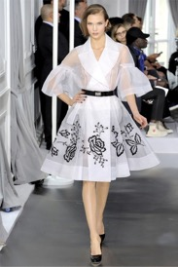**Thousands of dollars Approx. $8.50-Thrift Store**

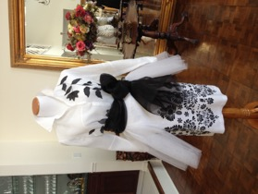

The organza sash is fabric purchased at Joann Fabrics for $3.00

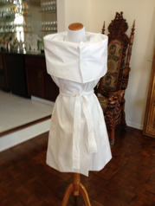 **Couture On sale at an off brand store- approx. $24.00**

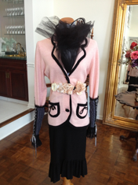**Couture**

**Thrift store/ Joann Fabrics: approx. $12.00 (wrist gloves a gift)**

Floral belt- Versona $11.00

**Couture Thrift and off-brand store: approx. $35.00**

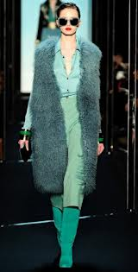

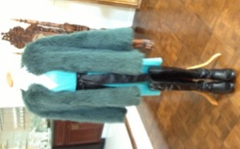

Boots bought on amazon- $29.99

**Couture $$$$$$$$**

**Thrift store approx. $7.00**



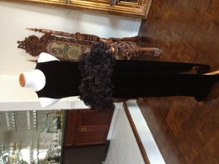

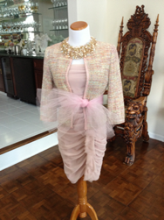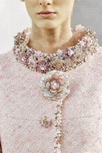

**Thrift approx….$6.50**

**Couture $$$$$$$$**

Purchased necklace at Aldo $69.00

**Thrift: Approx $6.00**

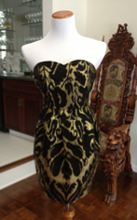

**Couture $$$$$$$**

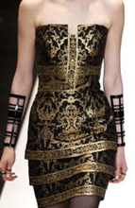

**Off brand store-approx. $17.00**

**Couture**

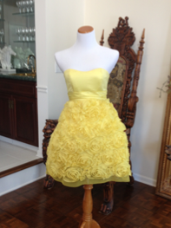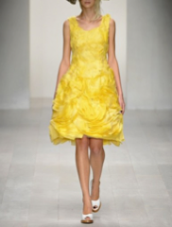

**(Continued)**

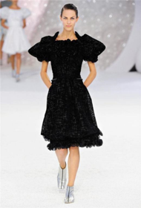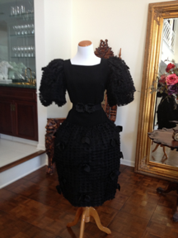

**Thrift store Approx. $24.00**

**Couture**

**Thrift Store: $4.75**

**$$$$$$$**



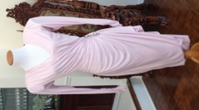

**Thrift Store: $4.00**

**$$$$$$$**



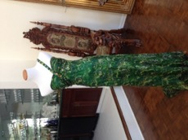



**$$$$$$$**

**Thrift Store: $ 6.00**

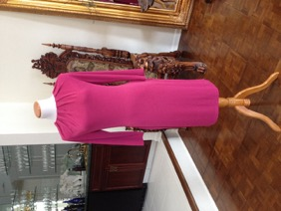

**$$$$$$$**

**Thrift Store: Approx. $9.00**

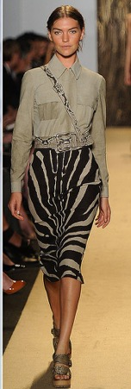

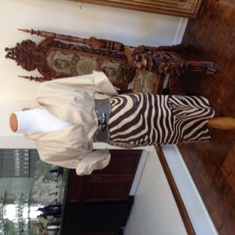

**$$$$$$$$$**

**Faux Fur Jacket: on sale $36.00/ Skirt and belt: thrift: $4.00/ Faux fur boot covers from Amazon :$ 21.95**

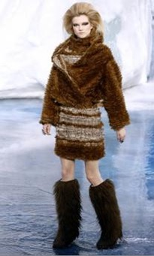

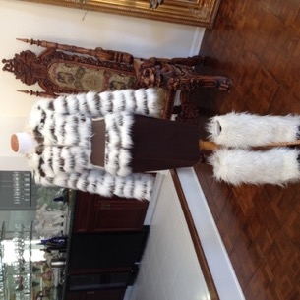

**Coat: off brand store: $9.99 Boots: resale shop: $24.00**

**$$$$$$$$**

